Reflection on Capturing Emotions in Motion: Observing a Crowded Temple Gathering
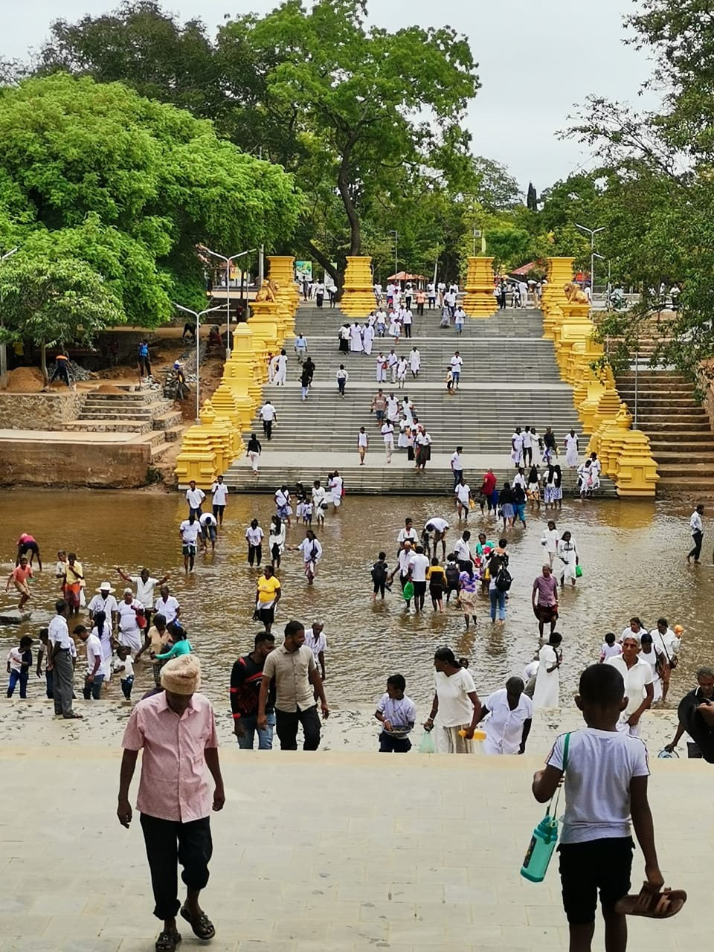
Before taking this picture, I felt a mix of curiosity and calm. Watching the flow of people moving up the temple steps and wading through the shallow water below, I noticed how connected everyone seemed. Some people walked with purpose, others were simply enjoying the moment, and a few took slow, reflective steps. The environment held a sense of reverence and community, with families and friends bonding over shared rituals.
After looking at the picture, I felt a deeper sense of appreciation for the simplicity and unity it captured. The variety of people from children to the elderly all participating in a shared experience, was heartwarming. It emphasized how public spaces like this temple become places for both personal reflection and communal connection, bringing people together in unique and meaningful ways. The image resonated with the theme of shared purpose and peaceful coexistence, reminding me of the quiet power of collective moments.

